Grade 1 Math Board
Use a deck of cards with the 10’s and Face Cards removed to complete the activities below.
Complete one activity each weekday. When finished, practice counting to 100 by 1s or 10s.
Monday | Week 1 | Week 2 | Week 3 | Week 4
 | Counting On  Using a deck of cards, turn over the top card and count on from that number to 30  Challenge:  Count on to 50 | Numbers  Using a deck of cards, count out 20 cards and make a pile. Turn over the top card and say the number’s name. Turn over another card and say its name.  For numbers 11-19, use an ace and another card. | One More  Using a deck if cards (Ace-9), count out 10 cards (this will be the draw pile).  Turn the other cards face up on the table. Turn over one card in your draw pile. Find a card on the table that is one more. | Sort by Colour  Sort cards into 2 sets.  Red and Black.  *Save these sets for tomorrow’s activity (Tuesday Week 4)
Tuesday | Model Numbers  Using a deck of cards, turn over the top card and count that many dry beans, cereal, noodles, LEGO, etc. | Patterns  Use a deck of cards to recreate patterns:  Red, black, red, black  5, 4, 5, 4, 5, 4, 5, 4  Heart, Diamond, Heart, Diamond | One Less  Using a deck of cards (Ace-9), count out 10 cards (draw pile).  Turn the other cards face up on the table. Turn over one card in your draw pile. Find a card on the table that is one less. | Sort by Shape  Sort the red cards into 2 sets.  Heart and Diamonds  *Save these sets for Thursday’s activity (Thursday Week 4).
Wednesday | More Than, Less Than, The Same as  Using a deck of cards (Aces-10), turn over two cards. Compare.  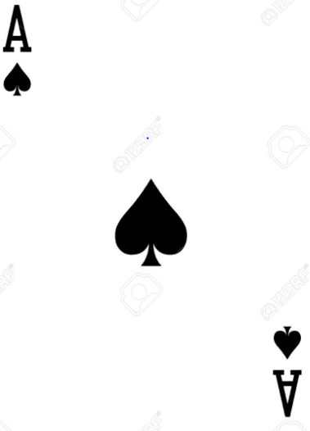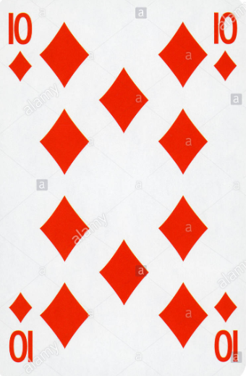  Say: 1 is less than 10 | Sorting  Give your child ten random cards to sort.  Ask them to describe how they sorted their cards.  By colour, shape, number? | Shape Hunt  Take a walk and find objects shaped like squares, triangles, circles and rectangles | Sort by Shape  Sort the black cards into 2 sets.  Spades and Clubs  *Save these sets for tomorrow’s activity (Thursday Week 4)
Thursday | Length  Find 6 different objects and order by shortest to longest.  This can be objects outdoors such as leaves, sticks, rocks, etc. | Heavier/Lighter  Take a walk and find objects that are heavier and lighter. Compare.  The leaf is lighter than the rock. | Longer/Shorter  Find sticks, leaves, bushes, trees, etc. and compare their length.  The bush is shorter than the tree. | Number Order  Take the spades and order then cards in number order from 1-10. Repeat with clubs, diamonds, and hearts.  *Save these sets for tomorrow’s activity (Friday Week 4)
Friday | Make Ten  Turn over 20 cards and find pairs o cards that make a total of 10 by counting the shapes on the cards. | Money  Sort a set of coins.  Name the pennies, nickels, dimes and quarters. | Make a Graph  Sort your pairs of shoes.  Sneakers, sandals, boots, etc.  Arrange each type of shoe in a separate row to create a graph.  Count to find how many of each. | Sort by Number  Using the sets of cards sorted by shape, sort the cards into sets by numbers. Put all the ones in a stack, all the twos in a stack, and so on.

